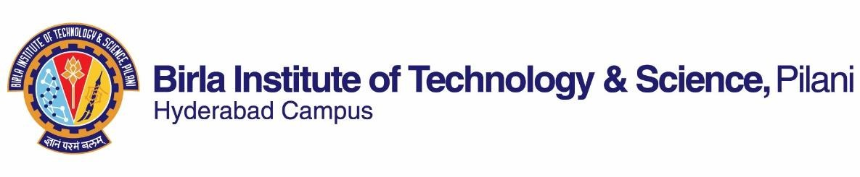

# FIRST SEMESTER 2019-2020

Course Handout Part II

Date: 17-08-2020

In addition to part-I (General Handout for all courses appended to the time table) this portion gives further specific details regarding the course.

*Course No.* : *PHY F213*

*Course Title* : *Optics*

*Instructor-in-Charge* : *Meenakshi Viswanathan*

## Scope and Objective of the Course:

This course provides a physical and mathematical background to understand naturally occurring optical phenomenon and technological tools which use optical physics. It is important to note you will be performing experiments which use optical physics principles in the forthcoming lab courses.

## Textbook:

1. Optics by Eugene Hecht and A. R. Ganesan, 4th Edition, Pearson (2008)

## Reference books

1. Optics by Ajoy Ghatak, 6th Edition, Tata Mcgraw Hill (2017)
2. Optics by Lipson, Lipson & Lipson, 4th Edition, Cambridge Univ Press (2010)

## Course Plan:

|  |  |  |  |  |  |  |  |  |
| --- | --- | --- | --- | --- | --- | --- | --- | --- |
| **Lecture No.** | **Learning objectives** | | | **Topics to be covered** | | | | **Chapter In Hecht** |
| 1 | Introduction | | | Overview of the course | | | |  |
| 2 – 4 | Derive the Eikonal equation of geometrical optics. State Fermat’s principle. Identify the underlying principle that connects mechanics and  optics. | | | Eikonal Principle. | Equation | and | Fermat’s | 3.1 – 3.2,  Ghatak, Class notes |
| 5 - 9 | To analyze the output of arrangement of various optical elements using ray tracing (matrix methods) by calculating the effect of translation and  refraction on paraxial rays. | | | Matrix methods in Ray tracing, cardinal points and planes. | | | | 5  Ghatak |
| 10 – 11 | Describe Huygens wave theory and understand superposition of waves. | | | Huygens’ principle, Superposition of waves | | | | 7.1 |
| 12 – 13 | Understand the basic coherence phenomenon. | physics | of | Spatial and Temporal Coherence | | | | 12.1 –  12.3,class notes |

|  |  |  |  |
| --- | --- | --- | --- |
| 14 – 19 | Use Fourier integral to define Fourier transform of a function, Analyze multidimensional form of Fourier transform | Fourier Transform and related relevant theorems, mathematical representations of slits and apertures | 7.3 – 7.5,  11.1 –  11.3.2,  Chapter 4 of Lipson |
| 20 – 31 | Analyze condition for Fraunhofer and  Fresnel diffraction, To derive, analyze and comprehend diffraction by various geometrical patterns by Fourier transformation, demonstrate the  Fourier transforming property of a lens.. | Diffraction from single slit and  multiple slits of different geometry, Fresnel half period zones and zone plate | 11.3.3-  11.3.4,  10.3, 10.4,  Chapter 7  and 8 of Lipson |
| 32 – 37 | Understand Youngs Interference  pattern, interpret the interference pattern and discuss the working of Michelson and Fabry Perot  interferometer. | Interference by division of wavefront  and division of amplitude | 9.3.1,  9.4.2, 9.6.1 |
| 38 – 41 | Understand the phenomenon of  holography | Analytical model for holography | 13.3 |
| 42 - 43 | Analyze polarized light | Malus law | 8.1 – 8.2 |

**Evaluation Scheme:**

|  |  |  |  |  |
| --- | --- | --- | --- | --- |
| **Component** | **Duration** | **Weightage**  **(%)** | **Date & Time** | **Nature of**  **Component** |
| Test 1 | 30 min | 15% | September 10 –September 20  (during scheduled class Hour) | Open Book |
| Test 2 | 30 min | 15% | October 9-October 20(during scheduled class hour) | Open Book |
| Test 3 | 30 min | 10% | November 10-November 20 during scheduled class hour) | Open Book |
| Quiz / Problem solving during lecture and tutorials, Assignment /  Presentation | variable | 25 % | Continuous | Open Book (No makeup) |
| Comprehensive Exam | 120 min | 35% | TBA | Open Book |

**Chamber Consultation Hour:** To be announced.

**Notices:** All notices concerning this course will be displayed on CMS.

**Make-up Policy:** It is applicable to the following case and it is permissible on production of evidential documents.

Debilitating illness.

## Academic Honesty and Integrity Policy:

Academic honesty and integrity are to be maintained by all the students throughout the semester and no type of academic dishonesty is acceptable.

# INSTRUCTOR-IN-CHARGE